**Ncorr - Open source 2D-DIC (Digital image correlation) MATLAB software**

**Reference:** J Blaber, B Adair, and A Antoniou, *"Ncorr: Open-Source 2D Digital Image Correlation Matlab Software."*  Experimental Mechanics (2015).

This software will be used to track the particles embedded in PDMS samples, to determine the strain of the samples during the tests. The strain values will be matched to the loading measured from the Instron machine.

1. Use the FileCreator.m program to select frames from your videos of the stress-strain experiment. It is suggested that you edit the movie file such that the frame closest to Xiangyu shouting out “Start” is the first and the sample failure is the last. The code will save frames from the movie at an interval set by you. It is suggested that one frame per 100 is reasonable.
2. After you finish selecting the frames, go to the webpage and download the Ncorr software from Github.

<http://www.ncorr.com/index.php/downloads>

<https://github.com/justinblaber/ncorr_2D_matlab>

Download ZIP and unzip the folder, rename the folder as: ncorr_2D_matlab

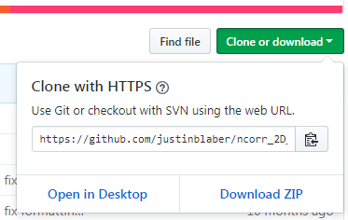

1. Download User Manual from the webpage:

http://www.ncorr.com/index.php/downloads

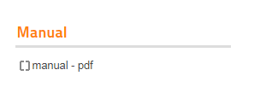

1. Open MATLAB, then, input command to setup MEX correctly:

>> mex –setup C++

**Note:** This software requires a C++ compiler. This step is to setup the compiler correctly. If you have trouble setting this up, please read the Ncorr Manual section about MEX setup.

1. Then input command to install the software:

>> cd ncorr_2D_matlab

>> addpath(pwd);

>> handles_ncorr = ncorr;

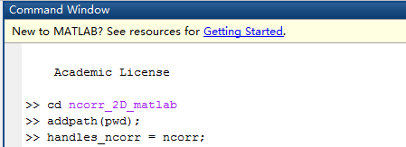

You will expect to see the interface:

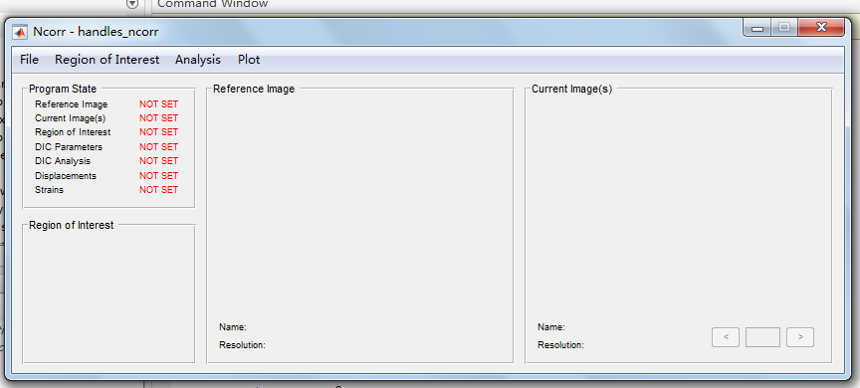

Then carefully read and follow the User Guide of the manual to perform the DIC analysis. You could also follow the video tutorial on the same webpage:

http://www.ncorr.com/index.php/downloads

**Note:** Please keep in mind that our PDMS samples experienced large strain. When you set up DIC parameters, you must check the box: High Strain Analysis:

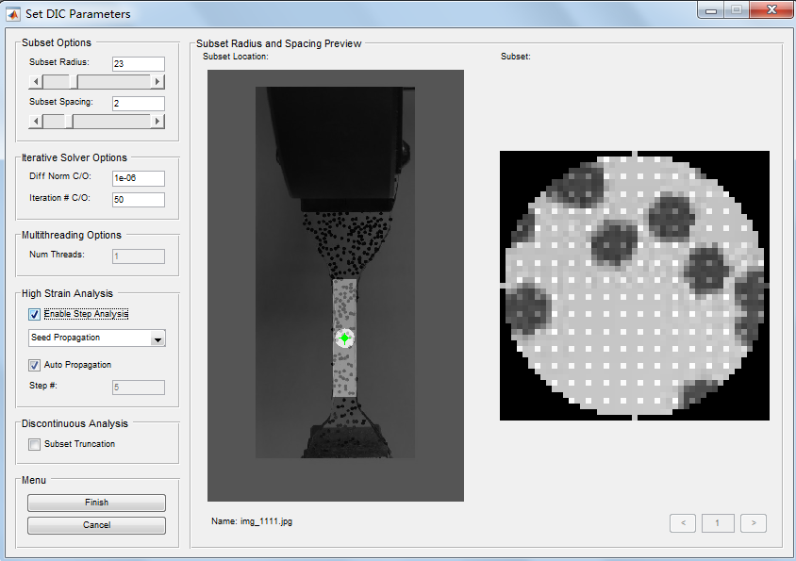

After you complete your analysis, you will be able to plot the strain in horizontal (Exx) and vertical (Eyy) directions. Here, we only care to estimate the strain in yy-direction.

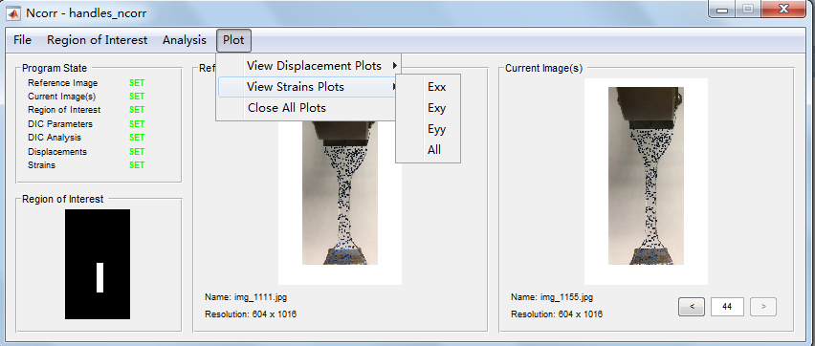

Then, set the Lowerbound of the display as -0.0005. If you go throught all the frames, you will read the estimated stain of each frame. (See the two red boxes in the following screenshot).

